***CALCULATOR***

**Operation : ADDITION**

|  |  |  |  |
| --- | --- | --- | --- |
| Steps | Correct result | Received result | Deviation |
| Enter “1” in the line number 1, “0” in the line number 2 , chlick button calculate | 1 | 3 | 2 |
| Enter “0” in the line number 1, “1” in the line number 2 , chlick button calculate | 1 | 3 | 2 |
| Enter “1.5” in the line number 1, “1.5” in the line number 2 , chlick button calculate | 3 | 5 | 2 |
| Enter “1.5” in the line number 1, “20” in the line number 2 , chlick button calculate | 21.5 | 23.5 | 2 |
| Enter “10” in the line number 1, “-11” in the line number 2 , chlick button calculate | -1 | 1 | 2 |
| Enter “-11” in the line number 1, “10” in the line number 2 , chlick button calculate | -1 | 1 | 2 |
| Enter “-100” in the line number 1, “-200” in the line number 2 , chlick button calculate | -300 | -298 | 2 |
| Enter “-25” in the line number 1, “2.5” in the line number 2 , chlick button calculate | 23.5 | 20.5 | 2 |

Conclusion : operation “addition” does not work exactly and gives a deviation of 2/adds 2 to the correct result/.

**Operation : SUBTRACTION**

Conclusion : operation “subtraction” works correctly and there is no calculation deviation .

**Operation : MULTIPLICATION**

Conclusion : operation “multiplication ” works correctly- all of the above examples were applied, but no deviation errors were reported .

**Operation : DIVISION**

Conclusion : operation “division ” works correctly- all of the above examples were applied, but no deviation errors were reported .

**Additional /errors/**

1. After performing the action, pressing button “Reset”, the values ​​entered in the “number 1”and “number 2” lines are not cleared, only the result is reset .

2. Removing the values entered which have been ​​entered before in the “number 1”and “number 2” lines, the value of the “Result” line is not reset, but is preserved.

3. Entering a number in the field “number 1” and meanwhile leaving the field “number 2” empty, the program allows us to press that button “Calculate”, after which only the following error window appears on the screen:

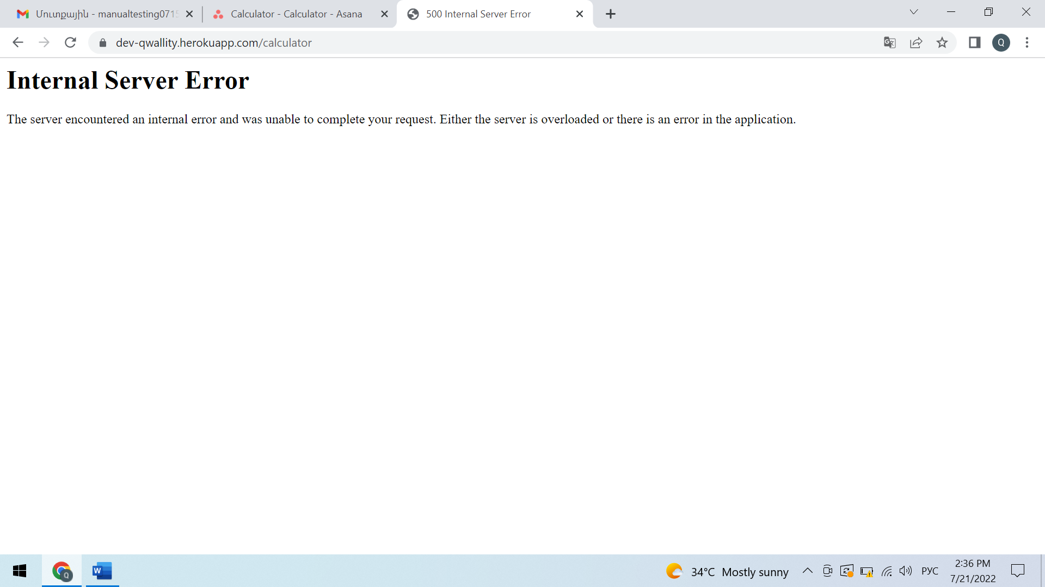

**Suggestions**

1. **Buttons '' calculate '' and ''reset '' look very similar at the first glance**
2. **It is more logical if ‘’result’’ is after button ‘’ calculate’’**
3. **Generally the information is unreadable**
4. **Some words are with capital letters , some are not**